**Capstone Project: Create a Testing Framework for Sporty Shoes Website**

**Testing Sporty Shoes website elements using selenium**

1. Setup or Configure Selenium

**Development Environment:**

* Postman
* JavaScript

This guide has three subsections, namely:

3.1.1 Creating a Request in postman

3.1.2 Pushing the code to GitHub repositories

**Step .1:** Creating a Request in postman

* Open postman
* Create a collection and add requests in it

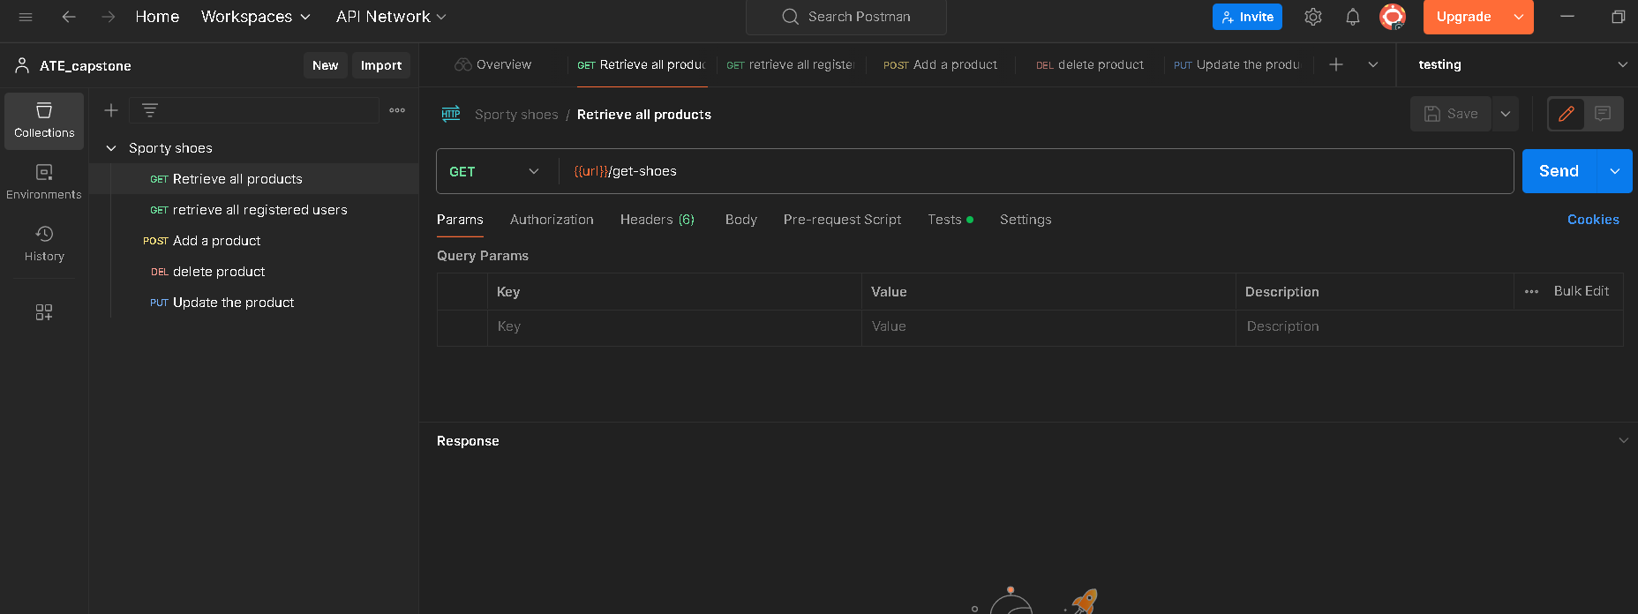

* Add tests using javascript in test section

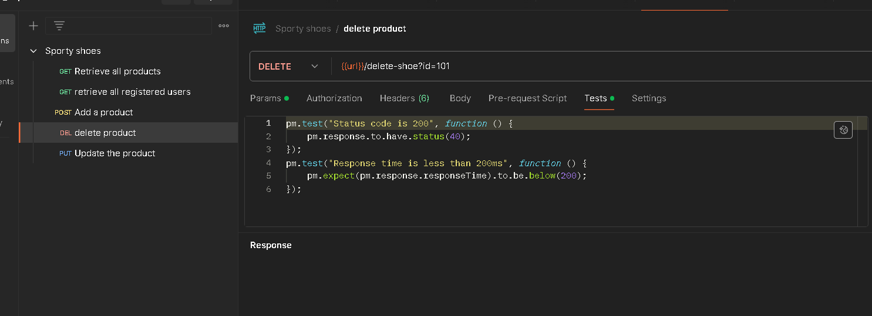

Push code to git repository

* Using git add .
* Git commit -m ”message”
* Git push -u <name> <link>